BMW Sales Analysis – Mini Project
1. Project Overview
The BMW Sales Performance & Market Analysis project focuses on analysing BMW vehicle sales data from 2010 to 2024 to gain insights into sales performance, model-wise comparisons, regional distribution, and vehicle characteristics.
The primary objective of this project is to demonstrate practical skills in data analysis, KPI development, data visualization, and business intelligence reporting using Microsoft Excel and Power BI. The analysis helps identify sales trends, evaluate market performance, and support data-driven decision-making.
2. Dataset Information
The project utilizes a CSV dataset containing BMW vehicle and sales-related data for the period 2010–2024. This dataset serves as the foundation for analysing sales performance, vehicle trends, regional distribution, and model comparisons across different markets.
Dataset Details:
- Dataset Format: CSV
- Analysis Period: 2010–2024
- Data Domain: Automotive Sales Analytics
- Primary Focus: BMW vehicle and sales-related records
- Dataset Source: Google Dataset Search (datasetsearch.research.google.com)
3. Problem Statement

- To analyse sales performance across regions and products to identify top-performing areas and profit trends.
- To understand customer purchasing behaviour to enhance marketing and retention strategies.
- Identifying top-performing vehicle models and understanding sales trends requires systematic data analysis.
- Regional sales performance varies across markets, making it difficult to determine high-growth and low-performing areas.

4. Attribute (Column/Features) Details

Attribute Name | Data Type | Description
Model | Text/String | Name of the BMW vehicle model (e.g., X5, 3 Series, 5 Series).
Year | Integer | Manufacturing or sales year of the vehicle.
Region | Text/String | Geographic region where the vehicle was sold or recorded.
Colour | Text/String | Exterior colour of the vehicle.
Fuel Type | Text/String | Type of fuel used by the vehicle, such as Petrol, Diesel, Hybrid, or Electric.
Transmission | Text/String | Transmission type of the vehicle, such as Manual or Automatic.
Engine | Decimal Number | Engine capacity measured in litters (L).
Mileage | Whole Number | Total distance travelled by the vehicle, measured in kilometres.
Price | Currency/Decimal Number | Selling price of the vehicle in U.S. Dollars (USD).
Sales | Whole Number | Number of vehicles sold for a specific model, region, or period.

5. Tools & Technologies

- Excel: Data cleaning, transformation, and Pivot Tables.
- Power BI: Data modelling, DAX calculations, visualization, and interactive dashboard creation.

6. Data Pre-Processing (Excel / Power Query)

Tasks Performed:

- Data Cleaning & Transformation:
Removed duplicates

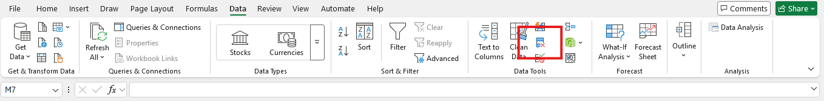

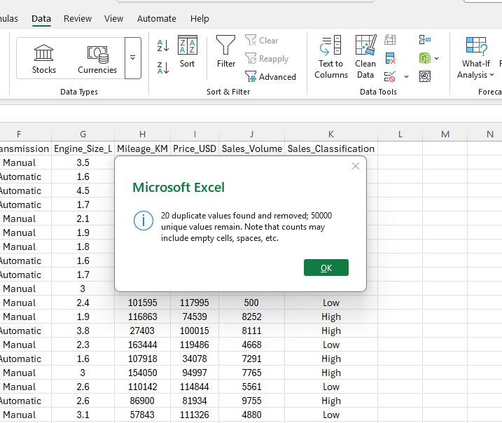
Found 20 Duplicate Values found across the data set and remove using remove duplicate in Excel.

Handled missing values

Filled missing values across the columns using the formulas listed below

- Model (=IF(ISBLANK(A2),"Unknown”, A2))
- Year (=IF(ISBLANK(B2),"None”, B2))
- Region (=IF(ISBLANK(C2),"Unknown”, C2))
- Colour (=IF(ISBLANK(D2),"Unknown”, D2))
- Fuel type (=IF(ISBLANK(E2),"Unknown”, E2))
- Transmission (=IF(ISBLANK(F2),"Unknown”, F2))
- Engine Size (=IF(ISBLANK(G2), XLOOKUP (A2, $A: $A, $G: $G,""), G2))
- Mileage (=IF(ISBLANK(H2),AVERAGE(H:H),H2))
- Price (=IF(ISBLANK(I2), AVERAGE (I: I), I2))
- Sales Volumes (=IF(ISBLANK(J2), AVERAGE (J: J), J2))
- Sale Classification (=IF(ISBLANK (K2),"Unknown”, K2))

Standardized formats

- Converted the data into a table format with no formatting errors identified.
- Filtered and sorted the data for the last five years
- Organized the data into three separate worksheets: Order Details, Sales Details, and Product Details.

Data Transformation Process:
- Imported the Order Details, Sales Details, and Product Details datasets into Power BI
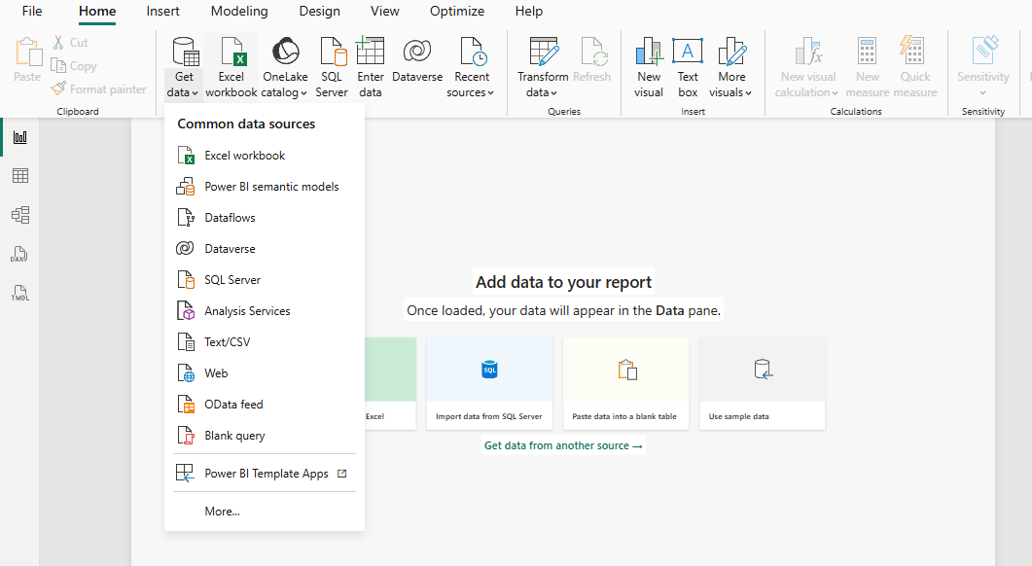

- Change the data type of “Price” column to ‘Fixed Decimal Number’.

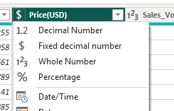

DAX Calculated Columns
- A calculated column was created by combining Fuel and Transmission to provide a more detailed product classification.
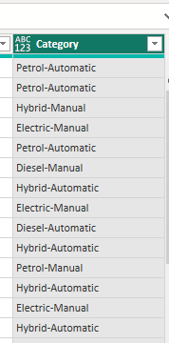

- A new column was created to calculate Revenue generated per order using the formula
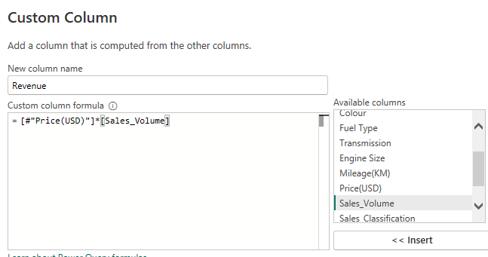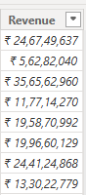
Data Modelling:

- Save and Moved the Data to PBI
- After saving, Power BI automatically generates a default table layout along with the initial relationships.
- Establish a relationship between the “Order details” and “Product details” tables using the ‘Model’ column.

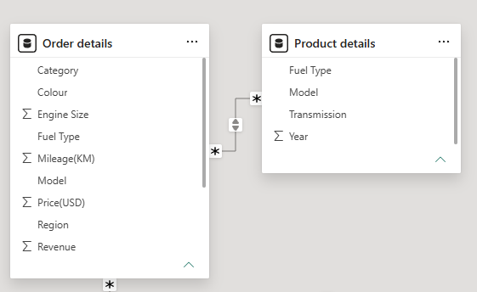
- Build a relationship between the “Order Details” and “Sales Details” tables based on the ‘Region’ column. Click "Manage relationships" and ensure this relationship is active.

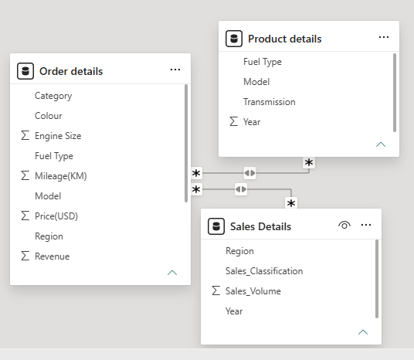

- Click "Manage relationships" and ensure this relationship is active.

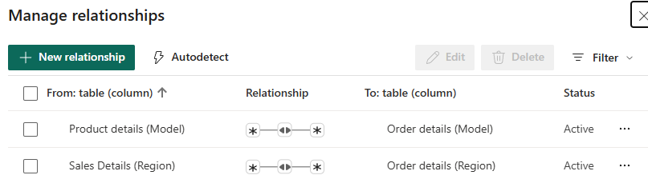
Data Visualizations
Yearly sales
A clustered column chart was used to compare actual Yearly sales across different region categories.
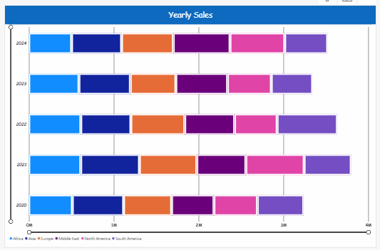
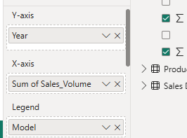
Region wise sales
A tree map visual displayed the contribution of different Region to total sales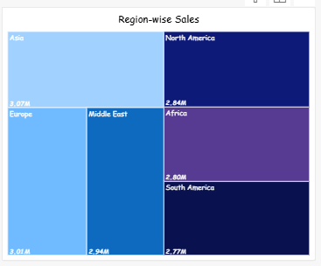 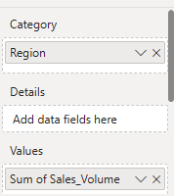
Order Count Analysis by State
A funnel chart illustrated the distribution of Sales across various Models.
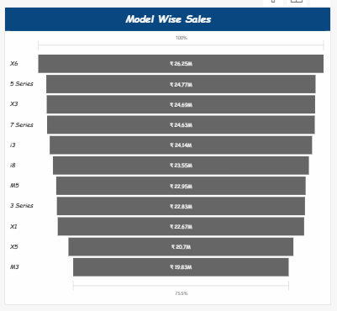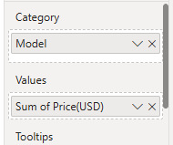
Mileage Analysis
A line chart displayed Models performance and highlighted overall sales trends over time.
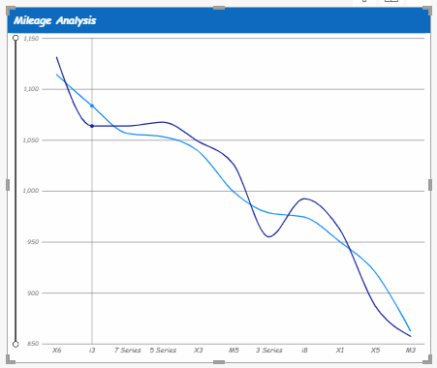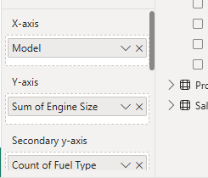

Sales Performance by Fuel type
A donut chart was created to identify Sales contributing the Fuel type

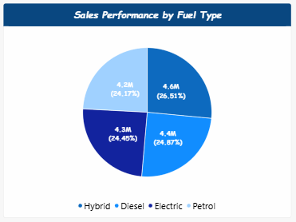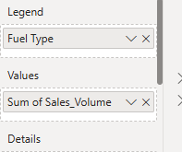
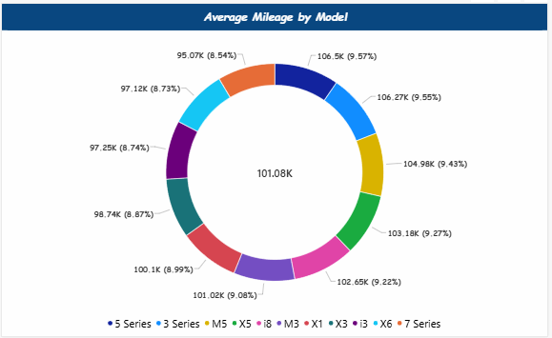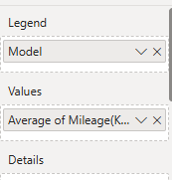
Customer colour preference
A scatter chart was used to examine the relationship between Customer choice for the colour and Models sold for different sub-categories.

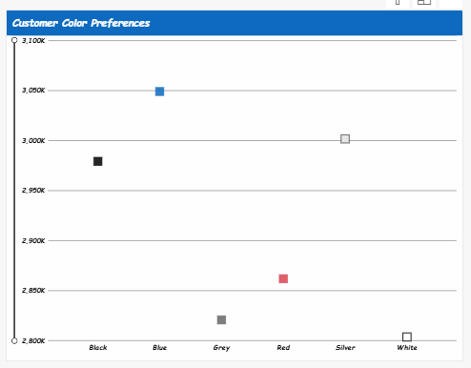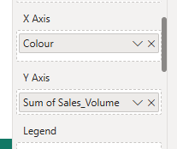

Sales Performance Matrix
A matrix visualization provided a detailed comparison of actual sales against by Models and month.
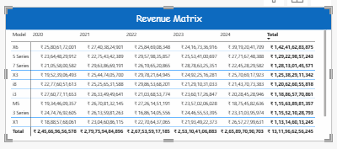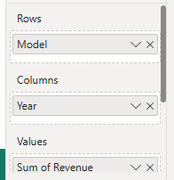
Revenue by year and model
A clustered column chart was used to compare actual Yearly sales across different product categories.
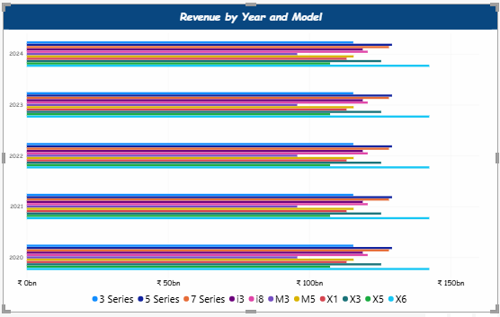
Revenue by Region
A Stacked column chart was used to compare actual Yearly sales across different Region categories.

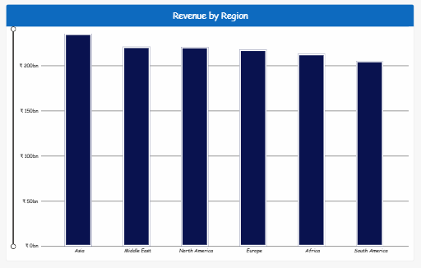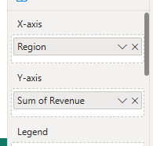

Mileage based Engine Reliability
An area chart was used to compare actual Engine reliability across different Engine categories.
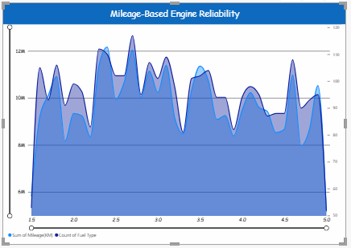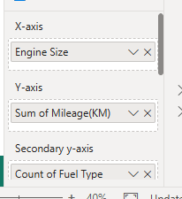

Dashboard
The final dashboard integrates all the above charts to provide Descriptive, Diagnostic, Predictive, and Prescriptive Analytics, enabling better decision-making and improving the sales and overall performance of the BMW brand.
Dashboard 1
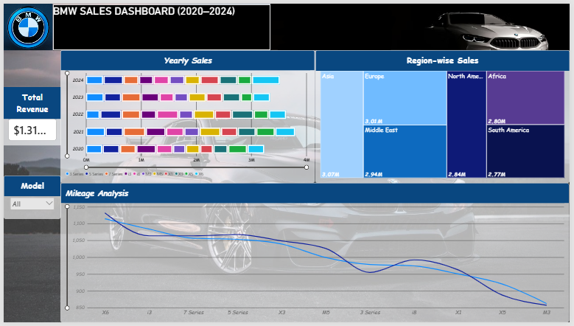

Dashboard 2
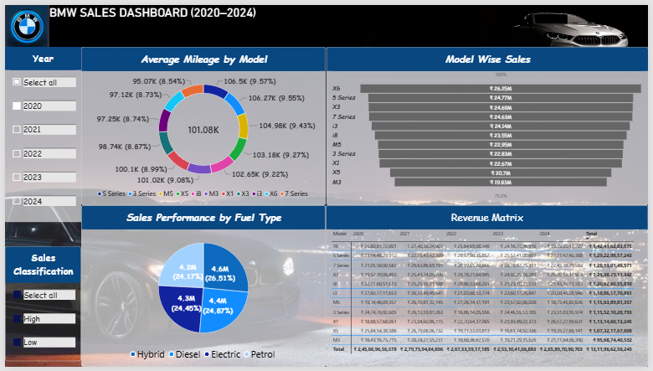

Dashboard 3


